Progress Report

I am currently implementing the game part.

Currently, the website can be run, but I found there is no use of implement a database and a scoreboard of a game where both players are human. I probably will change some features.

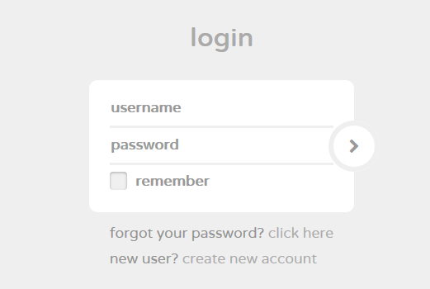

For the game part, it can be run already. However, I haven’t implement the score board part and how to win. It can only just be run. Here are some screenshots.

By the way, due to the time schedule, I probably won’t do a lot of security issues, which specifically, I will pass the entire game script to the client rather than holding a running session from the server end. However, it breaks the security, which shouldn’t really happened in a real world.

